The Harbor Ridge Homeowner
A Publication of the Harbor Ridge Homeowners Association Spring / Summer 2014
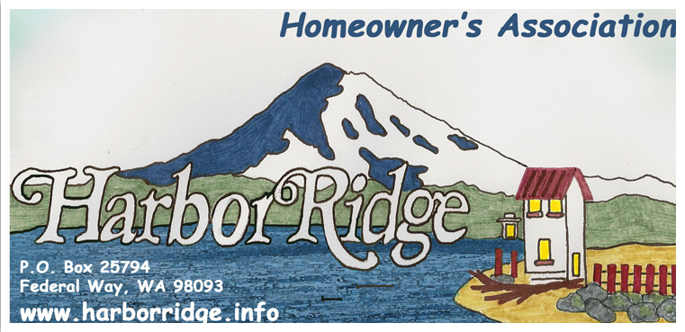

All Harbor Ridge homeowners are invited to participate in regularly scheduled Harbor Ridge Home Owner Board meetings. Meetings are normally held at 7:00 PM on the fourth Wednesday of the month. Before attending, we suggest you verify meeting location, time, and date by contacting Carole Kirkpatrick at: carolekirk@comcast.net or by phone at 253-927-4692. (Please leave a message) Other board member contact information is located on our web site at: http://harborridge.info/

Several CC&R violation notices were sent out last fall and winter. The prompt remedy of those violations is sincerely appreciated by all members of the Harbor Ridge community.

“BE GREEN” OPTION: Members are encouraged to receive periodic Newsletters by email instead of normal postal delivery. Several members take advantage of this option and we would love to increase that number. To sign up for email delivery, please contact: Carole Kirkpatrick, (contact information above), or visit our website at: www.harborridge.info/

The gray, cold, wet months of winter are behind us along with, we hope, the nasty spring storms that brought gale force winds and buckets of rain. Over flowing gutters and under-performing sump pumps can be shuffled to the background while we dust off mowers, blowers, trimmers, and other lawn tools. The growing season is upon us and that brings serious challenges to keep shrubs, trees, and weeds under control.

A new challenge was brought to us by the City of Tacoma. Trash, (green can), is picked up bi-monthly rather than weekly. An added factor is recycling of food-waste mingled with yard waste, (brown can), by some. With warm weather comes the possibility of food fermenting in a sun warmed trashcan becoming obnoxiously odiferous. Freezing food products, especially seafood waste, and then placing the frozen packets in your recycle bin the day of pick up is a viable option to help keep odors in check. Critters and insects may be attracted to trashcans containing food products for two week periods. We certainly have urban-coyotes , raccoons, and rats roaming our neighborhood at night. Most of us have seen them or signs of their midnight raids. Don’t let your trashcans become a smorgasbord for uninvited varmints.

Winter and spring storms damaged some neighborhood roofs. A quick check will determine if repairs are needed. Some cedar shake roofs remain in our community. If your shake roof is ending its service life and you plan to replace it with composition shingles, keep our CC&R regulations in mind before starting this expensive undertaking. Generally, composition shingles of architectural quality with a minimum forty-year guarantee are required. If you have any questions feel free to check with our Architectural Control Committee (ACC) by emailing them from our website at: www.harborridge.info/ architectural menu

Most of us will spend time away from our homes during the summer. Leaving our property unattended is becoming worrisome. Burglaries and car prowling is increasing in our community. Please be suspicious of unusual activities or strange vehicles on our streets. If something seems a little “off” take a photo. It can always be deleted, but it might help your neighbors recover prized golf clubs removed from their vehicle or heirloom jewelry burgled from their house.

Each day brings more and more sunshine. Here are several common sense precautions to keep in mind.
Avoid sun exposure between 10 a.m. and 4 p.m. Because the sun's rays are strongest during these hours, try to schedule outdoor activities for other times of the day. Seek shade whenever possible. If you're unable to avoid being in the sun, limit the amount of time you're outdoors during these peak hours.
Cover up. Wear tightly woven clothing that covers your arms and legs, and a broad-brimmed hat, which provides more protection than does a baseball cap or golf visor. Also consider wearing clothing or outdoor gear specially designed to provide sun protection.
Use sunscreen frequently and liberally. Use a broad-spectrum sunscreen with an SPF of 15 or greater. The American Academy of Dermatology currently recommends using a broad-spectrum sunscreen with an SPF of 30 or more. Apply sunscreen generously, and reapply every two hours — or more often if you're swimming or perspiring. Even the best sunscreen might be less effective than the SPF number on the bottle would lead you to believe if it isn't applied thoroughly or thickly enough, or if it's perspired away or washed off while swimming. Use it even on cloudy or hazy days. UV rays can penetrate cloud cover.
Wear sunglasses when outdoors. Look for a manufacturer's label that says the sunglasses block 99 or 100 percent of all UV light. To be even more effective, choose sunglasses that fit close to your face or have wraparound frames that block sunlight from all angles.

WEBSITE: Please visit our website at www.harborridge.info/. What will you find there? The Harbor Ridge By-Laws, Covenants, Conditions and Restrictions (CC&R’s), board members names and phone numbers, the Board’s meeting dates and much more. For example, check out Article IV, Section 7 and 18:
Section 7. All lots, whether improved or not, shall be fully maintained, including the control of any vegetation.
Section 18. Except with the approval of the ACC, no owner shall at any time keep or allow to be kept on their premises any commercial vehicle, house trailer, truck, camper, mobile home or boat trailer unless housed within a garage or suitably screen from view from any street or lot. For purposes of this provision, a vehicle will be deemed to be stored or kept if parked in driveways or streets for a period of longer than twenty-four (24) hours in any seventy-two (72) hour period.

VALUABLE INFORMATION:

For detailed information on Fighting Crime at Home: www.cityoftacoma.org/cro/FightCrimeathomebrochure.pdf
For City of Tacoma Resource guide: www.cityoftacoma.org/NeighborhoodCouncils/NCResourceGuideWEB.pdf
For Safe and Clean Brochure:
www.cityoftacoma.org/cityclerk/files/safeandclean/currentbrochure/5.2010.pdf
For the NE Tacoma monthly publication, the NET News:
- receive it in your e-mail by sending a note to netnews98422@hotmail.com, with ‘subscribe’ in the subject line, or
- regularly pick up a paper copy at any of these locations: Center at Norpoint, Kobetich Library, the Howards Corner and the Crescent Heights grocery stores, the TPD substation, North Shore Thai and the North Shore Cleaners (near Walgreens), the Cleaners by the QFC, and at Browns Point (the Diner, the Cleaners, and ACE hardware)
Tacoma Police / Fire / Medical:
Emergency – crime/threat in progress, fire, medical: 911
Police Non-Emergency – report crimes and suspicious behavior (wait for pickup): 798-4721 or 2
To report debris, junk vehicles and other nuisances: call Tacoma Cares at 253-591-5001.

NEIGHBORHOOD AWARENESS: At varying times, there are homes in our area that are vacated, for sale, or in foreclosure. Please be particularly aware of homes that are vacated, both for your sake as a neighbor, and in the interest of the owner. If you notice anything unusual, please report it to the owner, and possibly to the police.

Both in Northeast Tacoma and in Federal Way, unauthorized individuals have occupied vacated homes. The police department’s Community Liaison Officer (CLO) for our area is Officer Helen Stieben, 253-594-7951. She reported to the Neighborhood Council on that a certain individual gains access to such homes, subsequently re-keys the homes, and then rents them. The legal complexities of the situation make it difficult to have the new (perhaps unsuspecting) occupants removed.

